**Forget Me Not** Game Design Document

Table of Contents:

1. Concept...………………………………………………………………….Page 3
2. Influences………………………………………………………………….Page 3
3. Story………………………………………………………………………..Page 3

3.1 Premise………………………………………………………………..Page 3

3.2 Themes….…………………………………………………………….Page 4

1. Characters………………………………………………………………....Page 4

4.1 Rage………………………………………………………………...…Page 4

4.2 Depression………………………………………………………....…Page 4

4.3 Anxiety…………………………………………………………………Page 4

4.4 Stress…………………………………………………………………..Page 5

4.5 Frustration……………………………………………………………..Page 5

4.6 Apathy………………………………………………………………….Page 5

1. Enemies/Hazards……………………………………………………...….Page 5

5.1 Darkfeathers…………………………………………………………..Page 5

5.2 Fire Flowers…………………………………………………………...Page 5

5.3 Spikes………………………………………………………………….Page 6

1. Mechanics………………………………………………………………….Page 6

6.1 Core Gameplay Loop………………………………………………...Page 6

6.2 Winning/Losing Conditions………………...………………………..Page 6

6.3 Basic Controls…………………………………………………….…..Page 6

6.4 Ability Loop……………………………………………………..…......Page 7

6.5 Abilities…………………………………………………………………Page 7

6.5.1 Individual………..……………………………………………....Page 7

6.5.2 Combined…………………………………………….………....Page 7

1. Visuals……………………………………………………………………...Page 8
2. HUD………………………………………………………………………...Page 9
3. Menus……………………………………………………………………...Page 9

9.1 Main Menu…………………………………………………………….Page 9

9.2 Options………………………………………………………………...Page 10

1. Needed Assets…………………………………………………………..Page 10
2. Team members…………………………………………………………...Page 11

**1 Concept**

The game is envisioned as a puzzle-platformer for the PC aimed at a target audience of casual gamers between the age of 15-25. The player has to traverse a variety of levels in order to reach the end. He achieves this by switching between up to 3 characters and using their abilities in conjunction as well as combination with each other. The game contains 20 one-screen levels.

**2 Influences**

One of the biggest influences on the game’s overall aesthetic and feel is the 2009 Flash game "Fireboy and Watergirl". The idea to use simplistic characters also came from this game.

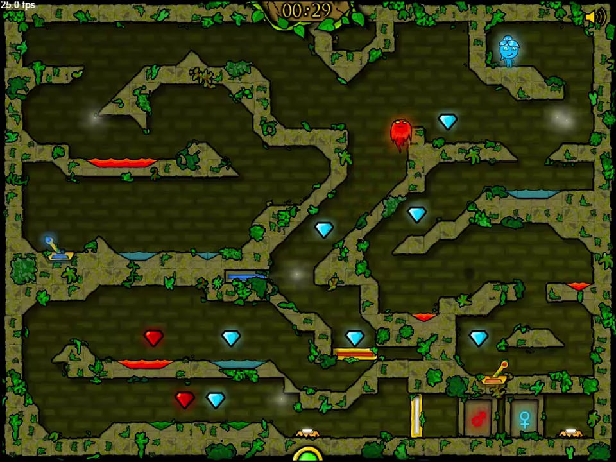

**3 Story**

**3.1 Premise**

The story follows the characters Rage, Depression and Anxiety, personifications of a person's negative emotions, as they find themselves split apart from the rest of the emotions. In order to once again combine into a balanced state of mind, they start their journey through a metaphorical representation of the human mind to return to their previous home.

**3.2 Themes**

The game takes place in a dark and unsettling cave, a metaphorical representation

of a person's mind that has become tainted by its negative emotions running out of control.

The games characters are all based on negative emotions, with the aim of showing multiple things. Firstly, this choice aims to show that negative feelings, like any others, do have their positive elements and can be used in a positive way. Secondly, the game highlights the importance and power of cooperation, seeing how the characters are only able to complete most of the levels by working together.

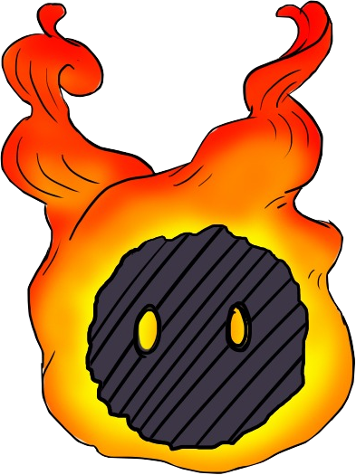

**4 Characters**

**4.1 Rage**

A small ball of anger that gets heated very quickly. It finds itself completely alone at the start of the game and can thus be considered the main character. Loses itself in anger once its ability is activated, causing it to dash forward in blind rage. Furthermore, its flames start burning even stronger. These effects can be used to break through certain walls, set of explosives, light flammable objects and push movable objects.

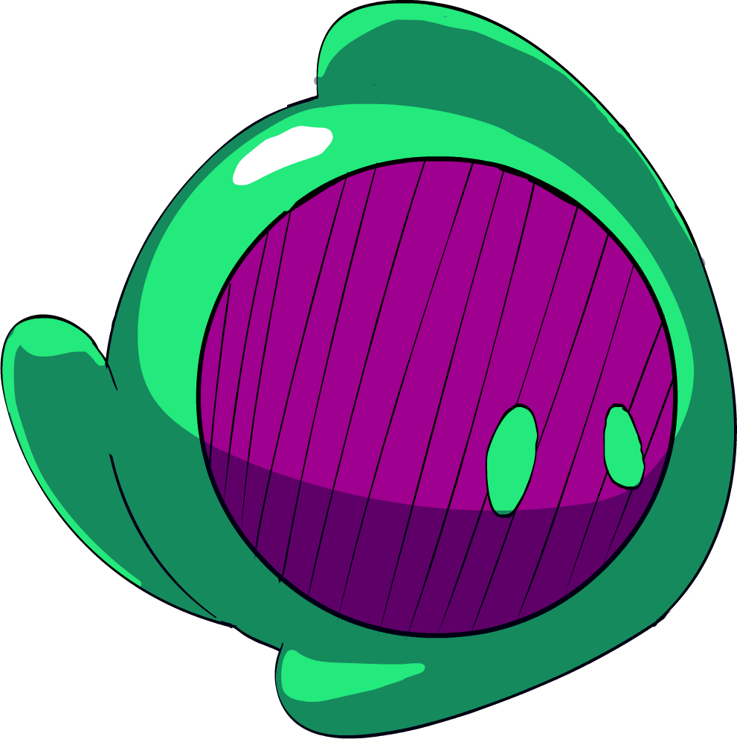

**4.2 Depression**

An accumulated mass of sadness that cries whenever it gets the chance. After being seperated from the other emotions, it simply started crying until Rage eventually meets up with it. Starts to cry uncontrollably when its ability is activated, which can be used to

fill containers with water or as a jetpack to reach high areas.

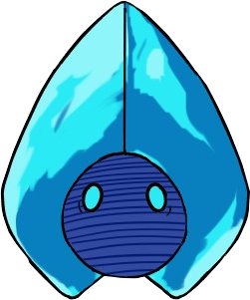

**4.3 Anxiety**

An easily frightened concoction of all kinds of fears. It froze up

once it realized that it was all alone until the others join it.

It freezes in place once its ability is activated, causing it to

become invulnerable and making projectiles repel from it.

**4.4 Stress**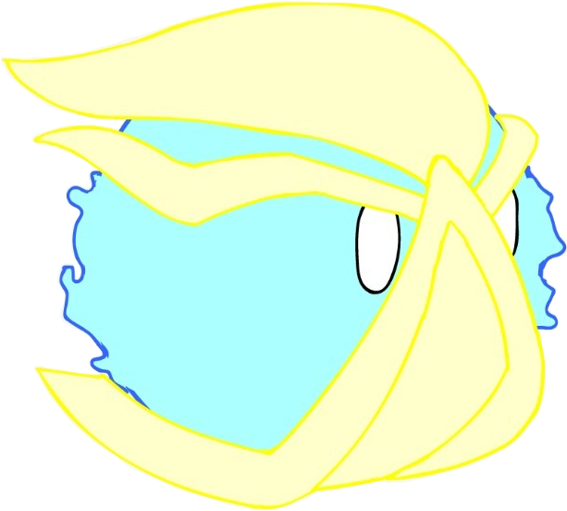

A combination of Rage and Anxiety which doesn't listen to any kind of reason. Will always charge forward without any concern for its surroundings, even putting itself in danger to reach its goal.

**4.5 Frustration**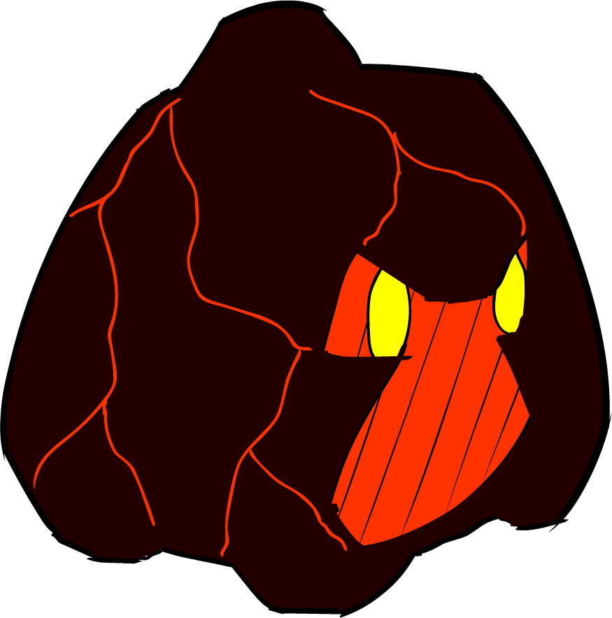

A combination of Rage and Depression that has been lost to despair. It finds no other way to express its feelings other than bringing all of its stored up feelings out in a stream of hot lava.

**4.6 Apathy**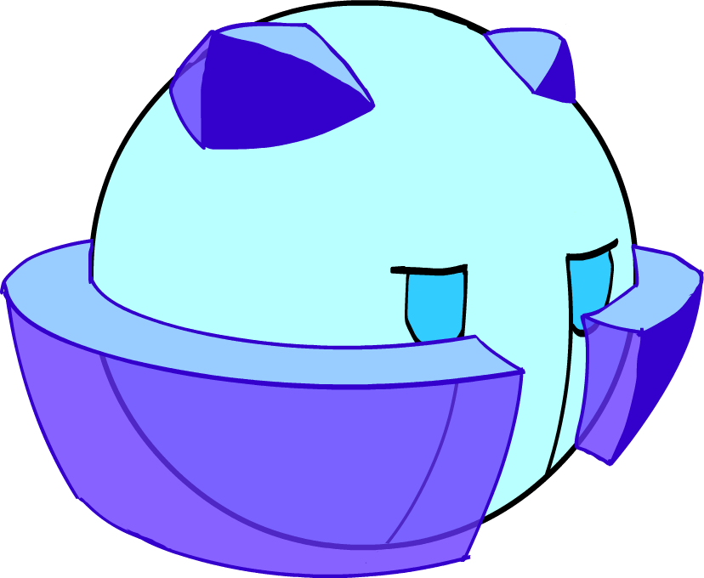

A combination of Depression and Anxiety that has shut

itself of from its surroundings. It sees no reason to do

anything anymore and has even lost its ability to cry normal

tears

**5 Enemies/Hazards**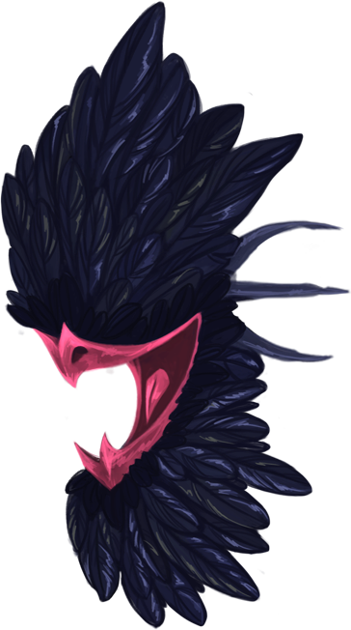

**5.1 Darkfeathers**

The darkfeathers have lived in the caves the characters find themselves in for such a long time that they have become one with their environments. Almost blending in completely with the walls they are attached to, they can catch unwary travelers off guard with their projectiles.

**5.2 Fire Flowers**

These floral inhabitants of the cave have adapted to their harsh living conditions in various ways depending on where they grew, resulting in different kinds of flowers with different properties. Their unique trait of using burning hot flames to ward of potential threats however has persisted through all incarnations.

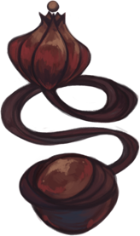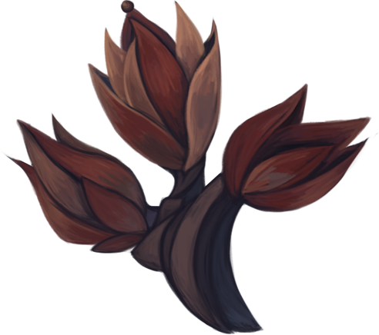



**5.3 Spikes**

These rock protrusions formed naturally over eons, resulting in sharp, deadly shapes that can easily pierce most life forms from a single touch.

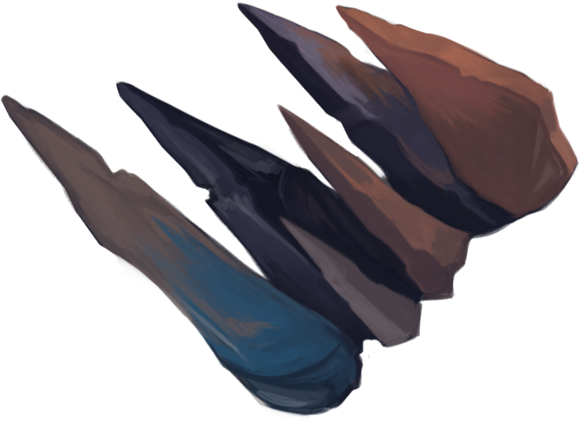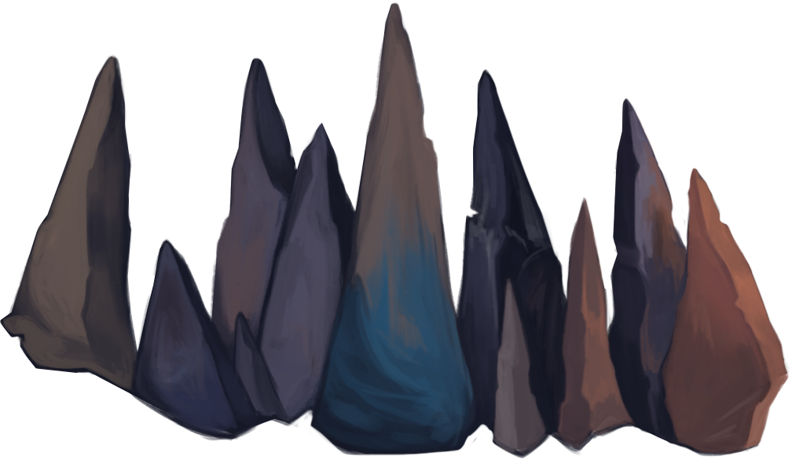

**6 Mechanics**

**6.1 Core Gameplay Loop**

The main part of the game consists of solving puzzles in order to bring all characters within the level to the exit. These puzzles involve the use of physics (e.g. floating objects on water, etc…), the use of interconnected mechanisms (e.g. levers, buttons, switches, etc…) and the use of the characters' abilities.

**6.2 Winning/Losing Conditions**

In order to finish the game, the player has to beat all the levels presented to him in the order they appear. This is achieved by bringing all characters present in any given level to the exit. Should a character be unable to reach the exit or take any form of damage before reaching it, the level will be considered as failed and the player must start again from the beginning of the level.

As of now, there is no implementation of a score system planned. Likewise, no forms of collectibles or time limits are planned.

**6.3 Basic Controls**

The player can move the currently selected character by using the A/D keys to move right or left and the W key to jump. In order to switch to a different character, he can press the Q key to cycle through the characters. To use an ability, the player has to press the E key. This holds true for both individual or combined abilities. To restart the level, he can press the R key.

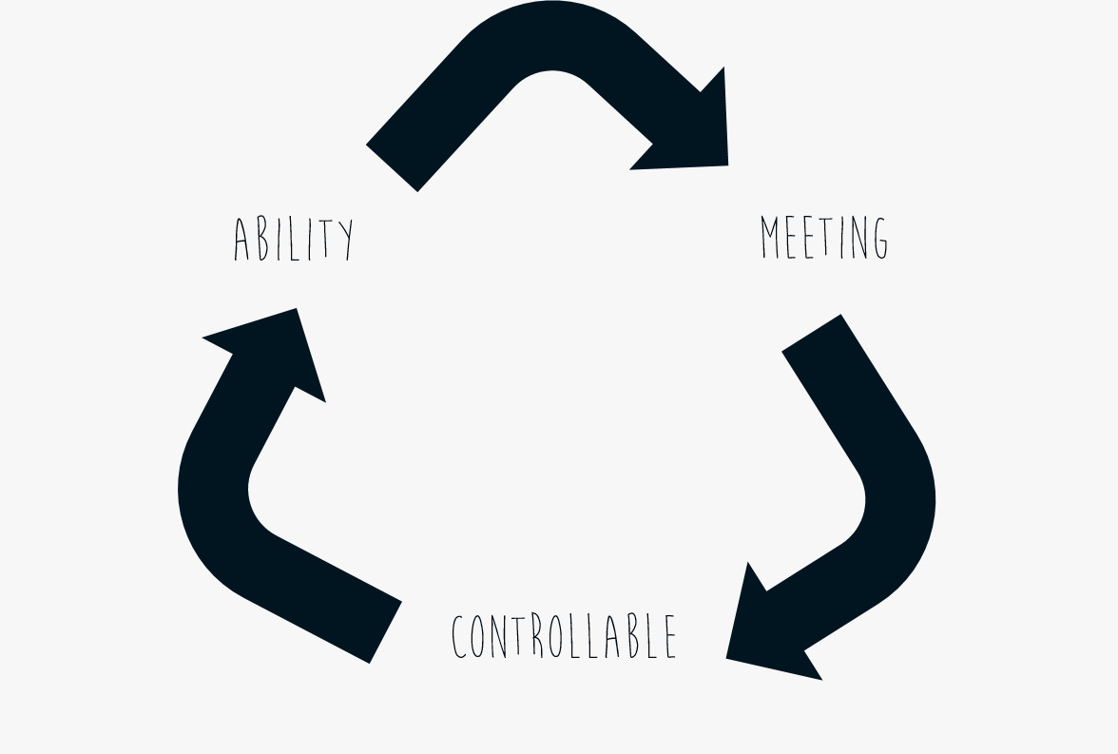

**6.4 Ability Loop**

Within any given level, characters always follow a certain loop once their ability has been activated. Before using their ability, they can be fully controlled by the player. After the activated ability has finished its animation, the player can no longer control that character and the game automatically switches to another one. The player then has to make the characters meet up in order to regain control over both of them.

**6.5 Abilities**

6.5.1 Individual

Rampage (Rage Idv.): Makes Rage dash forward and his flames burn stronger

* Can run through breakable obstacles
* Can light flammable objects
* Can move movable objects
* Can activate explosive objects

Crybaby (Dep. Idv.): Makes Depression cry a huge amount of tears.

* Can put out fires
* Can raise water levels
* Can be used as a jet-pack

Cold Feet (Anx. Idv.): Makes Anxiety freeze in place.

* Repels all projectiles
* Makes it invulnerable
* Can be used as a platform by other characters

6.5.2 Combinations

When the player activates an ability while two characters are grouped together, they will temporarily fuse together into a combined form. These forms can then use a new ability for the duration their combination lasts, which is envisioned to be less than 5 seconds.

Frozen Outrage (Stress): Combination runs very fast and becomes invulnerable

* Can run over hazardous terrain
* Can run through enemies to defeat them

Eruption (Frustration): Combination cries magma tears that harden immediately.

* Can be used to create paths

Icey Tears (Apathy): Combination can shoot controllable frozen tears.

* Can defeat enemies from a distance
* Can activate otherwise unreachable mechanisms

**7 Visuals**

The game features a striking contrast between the soft, more washed out and dim backgrounds and objects and the bright and colorful characters and animations. All assets are 2-dimensional and are drawn digitally by hand.

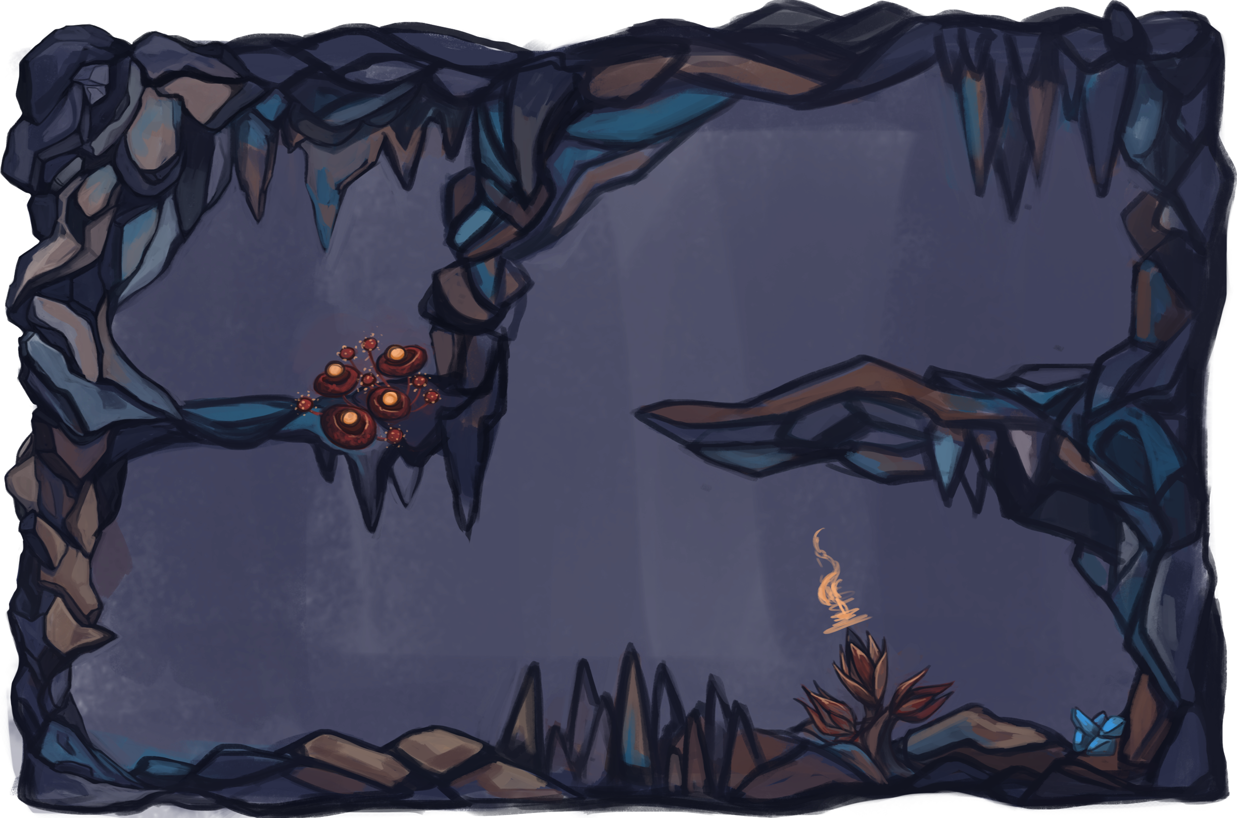



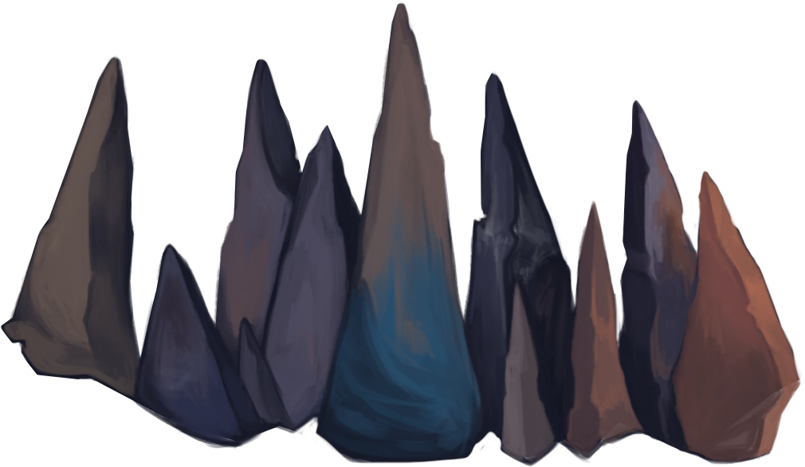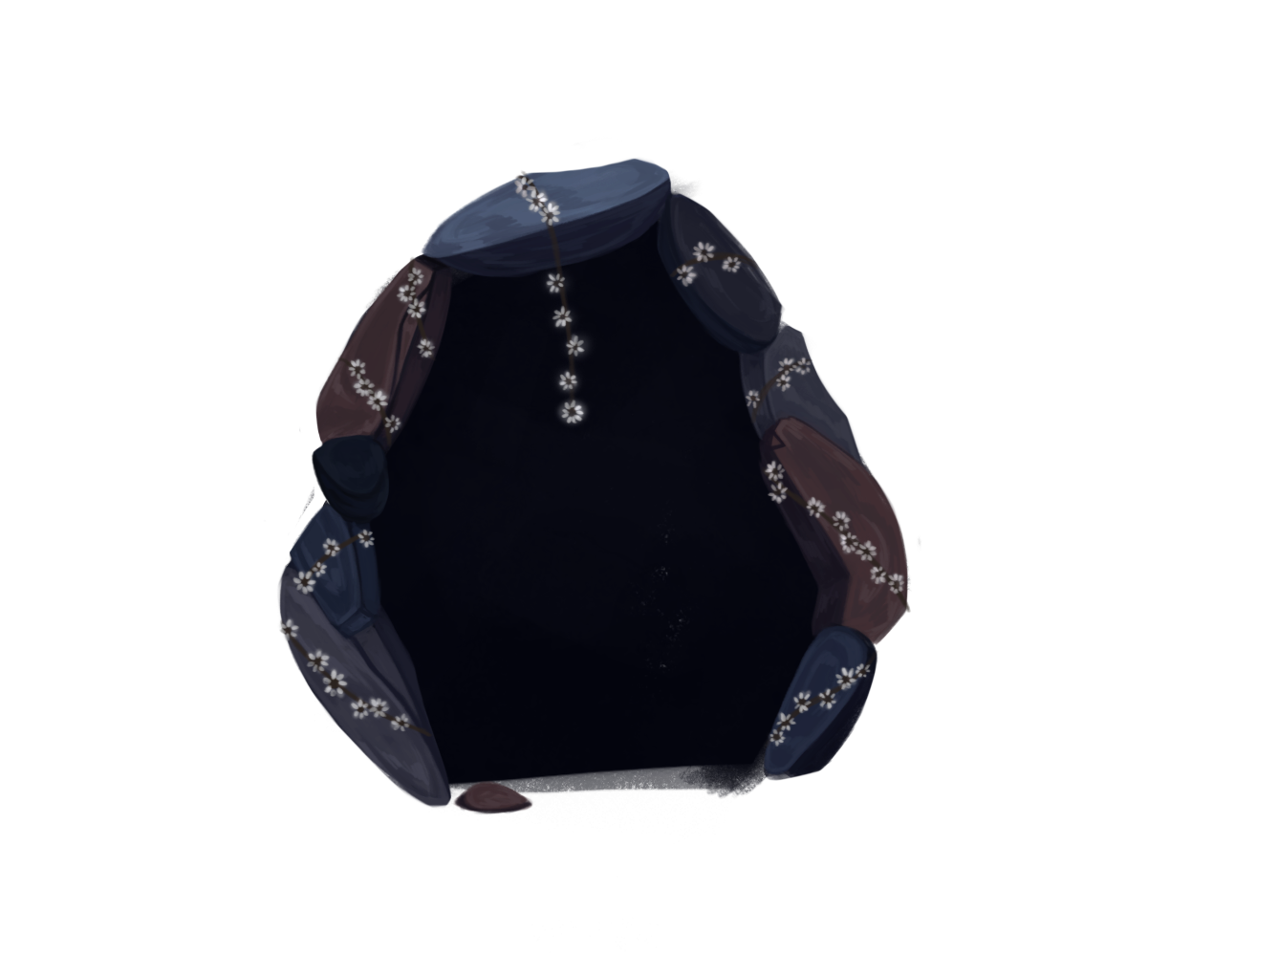

**8 HUD**

The game will feature a minimal amount of overlaid information in order to keep the player inside of the experience. Furthermore, most information will be relayed visual instead of through text. One part of this will be to have a soft glow around the character the player is currently controlling in order to make this easier to notice. The design of the HUD has not been finished yet, so there are no concrete plans yet. However, the decision to include a way to turn the HUD of has already been made.

**9 Menus**

**9.1 Main Menu**

The game will feature simple yet artistically pleasing and fitting menu art as well as design. The player will find the following choices within the main menu:

* New Game
* Continue (only available after having started a new game at least once)
* Glossary (only available after having started a new game at least once)
* Options
* Exit Game

Menus - New Game

Selecting this option will start the game from the beginning with a short introduction cutscenes and then bring the player to level 1.

Menus - Continue

Selecting this option will make the game resume from after the last level beaten by the player.

Menus - Glossary

Selecting this option will open the Glossary Menu (See section 8.2).

Menus - Options

Selecting this option will open the Options Menu (See section 8.3).

Menus - Exit Game

Selecting this option will close the game.

**9.2 Options Menu**

Selecting this option will open the Options Menu. Here, the player can adjust various settings of the game in order to enhance the experience for himself. The following adjustments can be made (list not final):

* Increasing/Decreasing Music Volume
* Increasing/Decreasing SFX Volume
* Activating/Deactivating HUD

**10 Needed Assets**

2D

* Background images
* Platforms
* Environments (Stones, Vines, Flowers)
* Interactable objects (Explosives, Elevator, Switches, Boxes)
* Exit
* Spikes
* Walls (Breakable and Normal
* Hazards (Spikes, Fire, Projectiles)
* Character animations (Idle, Walking, Jumping, Fusing)
* Ability animations (Individual and Combined)
* Intro Animation

Music

* Main Theme
* Different Level Themes (2-3)
* Intro Animation Background Music

SFX

* Character SFX (Walking/Jumping/Ability/Damage/Fusion)
* Environment SFX (Water/Fire/Wind)
* Actions (Breakable Wall/Moving Stone/Explosion/Fuse)

**11 Team Members**

Daniel Baracotti (Level Design/ Mechanic Design/Documentation) : [daniel.baracotti@web.de](mailto:daniel.baracotti@web.de)

Tamina Brunke (Level Design/Framework/Presentations): [taminabrunke@outlook.com](mailto:taminabrunke@outlook.com)

Sebastian Gerena (Character Design/Animations/Illustrations): [belmontx21@hotmail.com](mailto:belmontx21@hotmail.com)

Alba Plaep Golfe (Project Lead/Environment Design/Illustrations): [alba.plaep@gmx.de](mailto:alba.plaep@gmx.de)

Frederyk Sperling(Programming/Sound Design/Music): [mail@frederyk.de](mailto:mail@frederyk.de)